**Task 4 for submission**

*Part A addresses* ***Unit Objective 1 – Comprehend accounting concepts, principles and processes relating to accounting and end-of-month reporting for a service business.*** *The cognitive verb* ***explain*** *is a component of* ***comprehend*** *ie to show your comprehension of a concept, principle or process, you must explain the concept, principle or process.*

**Part A**

In a 100 – 150 word paragraph, **explain** the relationship between profit and net cash flow from operations.

Cash from operating activities are the receipts the business receives for performing its services. The payments for the operating activities are the expenses the business needs to pay to earn these receipts. Net cash from operating activities is shown in the Statement of Cash Flows by subtracting the cash payments from the cash receipts.

On the other hand, profit is determined in the Statement of Profit or Loss by deducting all expenses from all revenue. The relationship between profit and net cash from operating activities is that the operating revenue and expenses from the Statement of Profit or Loss form the basis for the operating section of the Statement of Cash Flows.

However, profit and net cash from operating activities are not exactly the same. This is because the Statement of Cash Flows shows movements of cash only. Profit is not the same as cash. This is why there is a separate statement devoted to the flows of cash.

*Part B addresses* ***Unit Objective 2 - Apply accounting principles and processes relating to accounting and end-of-month reporting for a service business.***

**Part B**

Refer to text book page 123 ex 4.18.

You are required to **apply** accounting principles and processes for a service business to:

* prepare a Statement of Cash Flows.

**Your response is to be handwritten**

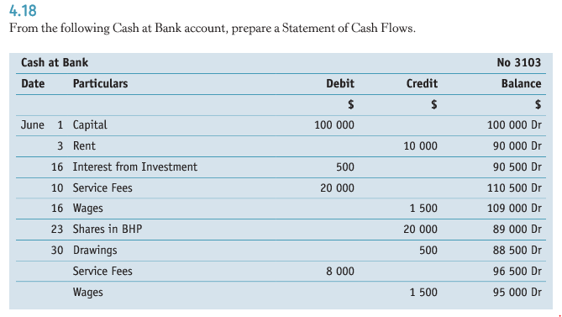

*Part C addresses* ***Unit Objective 3 – Analyse and interpret financial data and information relating to accounting and end-of-month reporting for a service business.***

**Part C**

You are required to:

* calculate the net profit ratio and return on owner’s equity ratio for each of the following.

**Your response is to be handwritten**

**(a) Service revenue $25 750; Other expenses $10 490; Capital (begin)$65 000.**

**(b) Service revenue $145 000; Other revenue $1 000; Other expenses $35 000; Capital $178 000 (begin); Drawings $26 400.**